Annual Plant Sale
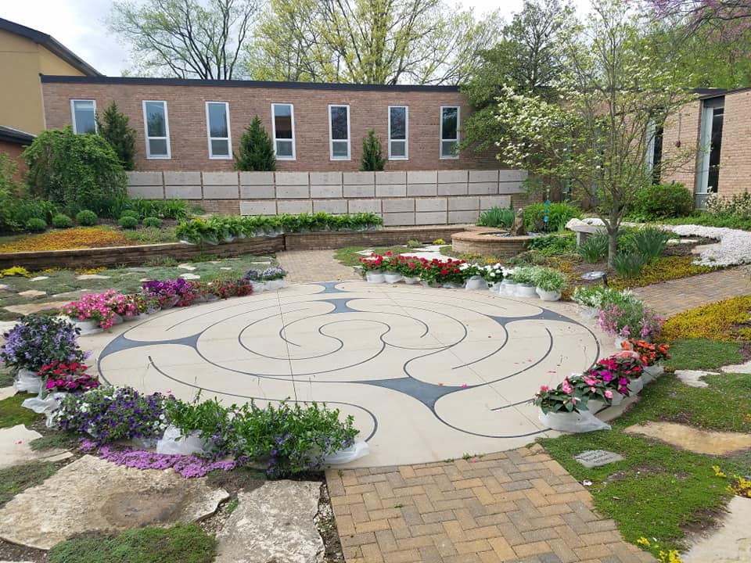

Hanging Blooming Baskets $20.00

Hanging Fern Baskets $25.00

Pick up Saturday, May 4th

9-Noon at St. Timothy’s Episcopal Church

808 N. Mason Rd., 63141
  - Name:__________________ Cash_______ Check______
  - Blooming Basket(s)_____ Fern Basket(s)_____

