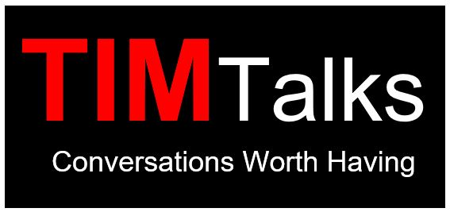

St. Timothy’s Episcopal Church
Fall 2020 Adult Forums, Sundays 9:45
Contact atconard@gmail.com for zoom info.

Sept 13th “Coffee with our Interim” – Join us in an informal session with our new interim Rev. Liz Meade.
Sept 20th "Episcopal City Mission" – An ECM Chaplain will discuss the pandemic's impact on the youth in detention and on the detention center staff, and highlight the ways ECM has changed its approach to serve the youth in this difficult time.

Sept 27th “Sharing the ‘Good News’ of St. Timothy’s through Social Media” - How to use opportunities to build genuine community and let your friends see your perspective through Social Media platforms.

Oct 4th “Stewardship Campaign 2021” – A stewardship campaign during a pandemic? Why stewardship at St. Tim's is more important than ever!

Oct 11th, 18th, 25th “The Scottish Episcopal roots of our Eucharistic Theology” – These three sessions will provide a window into how the Scottish Episcopal eucharistic theology came to be different from that in the 1662 English Book of Common Prayer, how the Scottish liturgy influenced our own first prayer book, and how a particular fourth-century liturgy that the Scottish bishops used in liturgical revisions in their day is particularly relevant in our time. Dr. Donna Hawk-Reinhard, Director, Anglican House of Studies, Eden Seminary.

Nov 1st “Important COVID-19 Information” –Dr. Jim Hinrichs will speak to us as the Division Director of Communicable Disease Responses with the St. Louis County Department of Public Health. Throughout his medical career, Dr. Hinrichs has treated people in many parts of the world as an Infectious Disease Specialist.

Nov 8th “Re-imagining Evangelism” –Newly appointed Canon for Evangelism in the Diocese of Missouri, The Rev. Canon Whitney Rice will lead a discussion about what evangelism looks like in our new reality, as well as how the church can continue to stand confident in the gospel and in its mission to spread the Good News of Jesus Christ.

Nov 15th “Hannukah: The Real Story of a Jewish-American Holiday” - Rabbi Daniel Bogard joins us again to share his insights and perspective.

Nov 22nd Diocesan Convention Report – Come and hear from our delegates about the Episcopal Diocese of Missouri.

Nov 29th Advent Event - Come prepare for a Holy Advent.

Dec 6th, 13th, and 20th “Communication Breakdown” – In today’s world, it feels almost impossible to communicate with those we disagree with, and even with those we do agree with. The Christian tradition has a long history of reflecting on the difficulty of communication, and on language in general. In these sessions we will ask what it means to talk theological about language and communication. The Rev. Dr. Adam Ployd, Assistant Professor, Eden Theological Seminary.

Jan 3rd– No Adult Forum

Jan 10th– The Legacy of Dr. H. Phillip Venable” - Local historian, James Singer, will speak to us about the racial segregation effort that led to the building of Beirne Park in the City of Creve Coeur and Dr. H. Phillip Venable, the prominent black doctor who fought the city's efforts.

Jan 17th Meet the Candidates – Come hear from the candidates for Vestry, Diocesan Convention delegate, and Endowment Committee.

