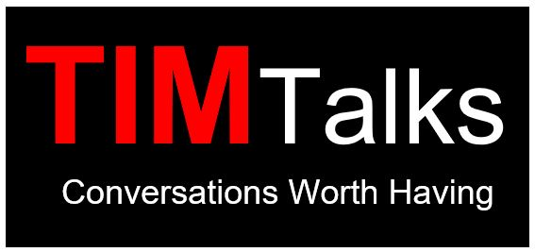

St. Timothy’s Episcopal Church
Spring 2021 Adult Forums, Sundays 9:40

Jan 31st and Feb 7th “Race, Faith, and American Public Safety” - The Rev. Dr. Ben Sanders (Assistant Professor of Theology and Ethics at Eden Theological Seminary) will return to St. Timothy’s teach on the topic “Race, Faith, and American Public Safety.” In the midst of America’s most recent eruption of racial animus lies a concept that is too little examined, this concept is “public safety.” Contemporary efforts toward resisting structural racism and transforming law enforcement policy will bear little fruit if we do not thoroughly examine our sense of what it means to be “safe” in “public.”

Feb 14th "School to Prison Pipeline" – Joy Weese Moll will speak to us about the history, the current situation and the ways we might improve it.

Feb 21st "Spiritual Care and the Black Lives Matter Movement" – How do we care for the bodies and souls of black folk? How do we care for victims of systematic racism, oppression, social injustice and state-sanctioned violence? How can we discern the relationship between our personal biases and what we are called to do as members of the Beloved Community? The Rev. Shug Goodlow

Feb 28th “Spiritual Self-Care” – Mary Taylor will speak about spiritual direction and its role in self-care as well as meditation as a spiritual practice.

March 7th “Coffee with Camie” – We invite you to join in conversation about her work with us and her perspectives on growing formation at St. Tim’s.

March 14th “Seeing a New Rector” Canon Doris Westfall will speak about how parishes seek a new rector and how to discern what we are looking for.

March 21st “Self-Care” – Joy Millner, Founder and co-Director of Fit & Food Connection, will share how small changes in all areas of holistic wellness can lead to big results.

March 28th “Coffee with Liz” – We invite you to join in a conversation about her work with us and her perspectives on St. Timothy’s.

Apr 4th Easter

Apr 11th “Adaptive Leadership in Challenging Times” –The Rev. Canon Whitney Rice, Canon for Evangelism & Discipleship Development. The upheavals of the pandemic, the economic downturn, and the renewed call to racial justice have all of us facing new needs and challenges in our faith communities. Those challenges call for new practices of leadership. Drawing on the work of Ronald Heifetz and Edwin Friedman, we'll explore the intersection of Adaptive Leadership and Family Systems Thinking to guide us to practical leadership methods and inspirations in a time of unprecedented opportunities for healthy change.

Apr 18th “Wings of Hope - Changes and saves lives through the power of aviation” – Bernie Schmidt, the Director of Volunteer Fulfillment for Wings of Hope, will speak to us about the work of this great organization.

Apr 25th “Deaconess Anne House” The Rev. Michaelene Miller, Director of the Deaconess Anne House, will come to speak to us about her work and those in the Episcopal Services Corp.

May 2nd “St. Timothy’s Youth” – Come hear from our youth about their experiences and hopes for St. Timothy’s.

May 10th Mother’s Day – please celebrate your family.

May 16th and 23rd “Each Other’s Keeper” – Beginning of a 6 part series developed by The Rev. Marc Smith on the church’s response to violence.

